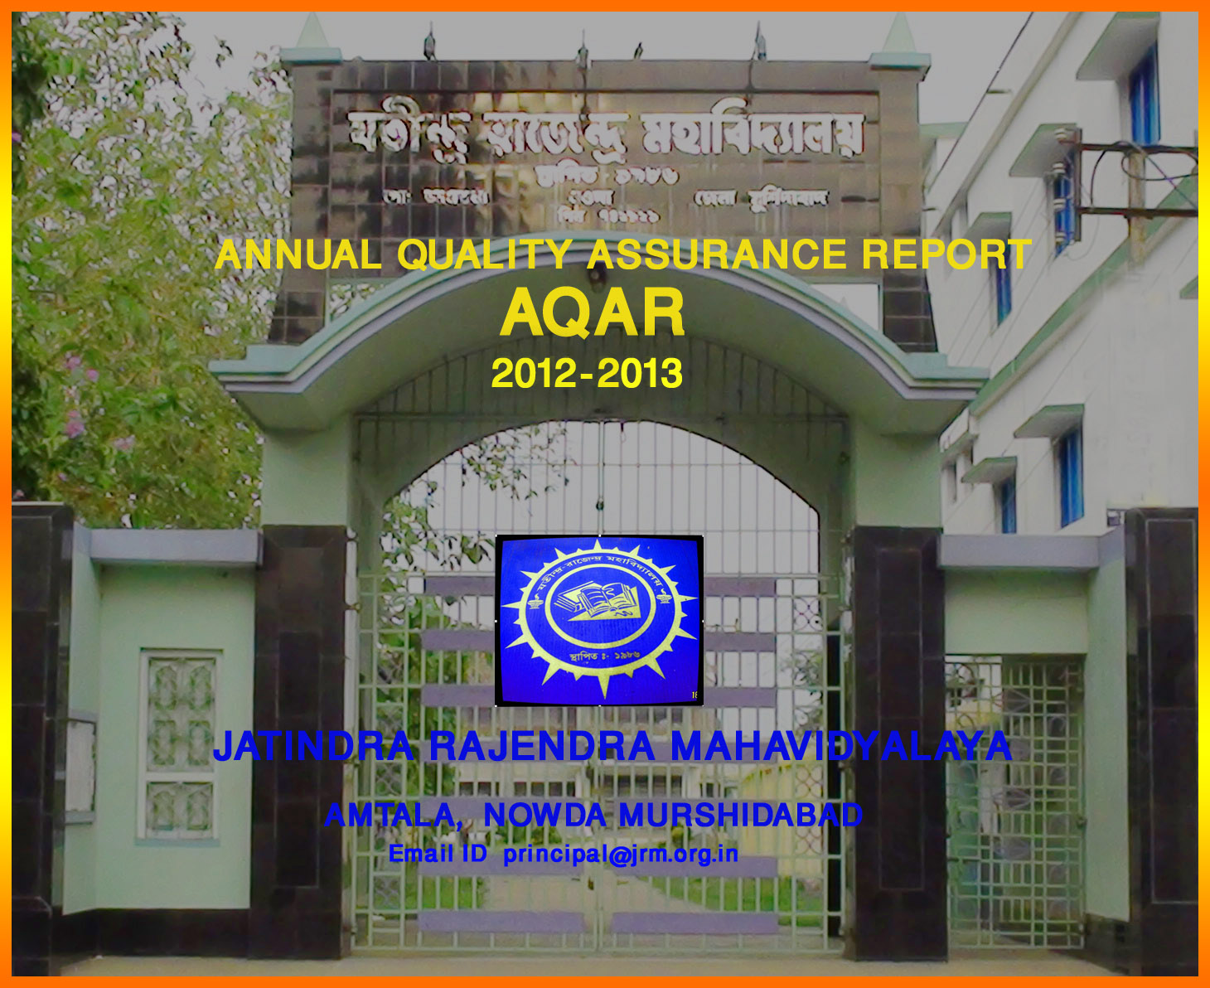

The Annual Quality Assurance Report (AQAR) of the IQAC

All NAAC accredited institutions will submit an annual self-reviewed progress report to NAAC, through its IQAC. The report is to detail the tangible results achieved in key areas, specifically identified by the institutional IQAC at the beginning of the academic year. The AQAR will detail the results of the perspective plan worked out by the IQAC. (Note: The AQAR period would be the Academic Year. For example, July 1, 2012 to June 30, 2013)

Part – A
2012-13
AQAR for the year (for example 2013-14)

1. Details of the Institution
Jatindra Rajendra Mahavidyalaya
1.1 Name of the Institution
P 0 - AMTALA
1.2 Address Line 1
DIST - MURSHIDABAD
Address Line 2
AMTALA
City/Town
WEST BENGAL
State
742121
Pin Code
principal@jrm.org.in

Institution e-mail address
03482 -247244 & 03482 – 247107.
Contact Nos.
GEETALI BERA
Name of the Head of the Institution:
03482 - 247905
Tel. No. with STD Code:
09434687179
Mobile:
SUCHARITA MITRA
Name of the IQAC Co-ordinator:
09732656465
Mobile:
sucharitamitra22@gmail.com
IQAC e-mail address:

WBCOXX13314
1.3 NAAC Track ID (For ex. MHCOGN 18879)
OR

1.4 NAAC Executive Committee No. & Date:
March 31, 2007/241
(For Example EC/32/A&A/143 dated 3-5-2004.
This EC no. is available in the right corner- bottom
of your institution’s Accreditation Certificate)

1.5 Website address:
www.jrm.org.in

Web-link of the AQAR: http:// www.jrm.org.in /AQAR2012-13.doc

1.6 Accreditation Details
Sl. No. | Cycle | Grade | CGPA | Year of Accreditation | Validity Period
1 | 1st Cycle | C++ |  | 2007 | 5
2 | 2nd Cycle
3 | 3rd Cycle
4 | 4th Cycle
1.7 Date of Establishment of IQAC :
29.01.2014

1.8 Details of the previous year’s AQAR submitted to NAAC after the latest Assessment and Accreditation by NAAC ((for example AQAR 2010-11submitted to NAAC on 12-10-2011)
- AQAR _______________________ __________________ (DD/MM/YYYY)4
- AQAR__________________ ________________________ (DD/MM/YYYY)
- AQAR__________________ _______________________ (DD/MM/YYYY)
- AQAR__________________ _______________________ (DD/MM/YYYY)
1.9 Institutional Status
√

University State Central Deemed Private

Affiliated College Yes No
√

Constituent College Yes No

√

Autonomous college of UGC Yes No

√

√

Regulatory Agency approved Institution Yes No
(eg. AICTE, BCI, MCI, PCI, NCI)
√

Type of Institution Co-education Men Women

√

Urban Rural Tribal

√

√

√

Financial Status Grant-in-aid UGC 2(f) UGC 12B

Grant-in-aid + Self Financing Totally Self-financing

1.10 Type of Faculty/Programme
√

Arts Science Commerce Law PEI (Phys Edu)

TEI (Edu) Engineering Health Science Management

Others (Specify)

1.11 Name of the Affiliating University (for the Colleges)
UNIVERSITY OF KALYANI

1.12 Special status conferred by Central/ State Government-- UGC/CSIR/DST/DBT/ICMR etc: N/A

Autonomy by State/Central Govt. / University

University with Potential for Excellence UGC-CPE

DST Star Scheme UGC-CE

UGC-Special Assistance Programme DST-FIST

UGC-Innovative PG programmes Any other (Specify)

UGC-COP Programmes
2. IQAC Composition and Activities
7
2.1 No. of Teachers
2
2.2 No. of Administrative/Technical staff
0
2.3 No. of students
2.4 No. of Management representatives
Nil
2
2.5 No. of Alumni
2. 6 No. of any other stakeholder and
Nil
community representatives
1
2.7 No. of Employers/ Industrialists
1
2.8 No. of other External Experts
2.9 Total No. of members
13
2.10 No. of IQAC meetings held

2.11 No. of meetings with various stakeholders: No. Faculty
03

03
Non-Teaching Staff Students Alumni Others

2.12 Has IQAC received any funding from UGC during the year? Yes No

√

If yes, mention the amount
2.13 Seminars and Conferences (only quality related) Nil
(i) No. of Seminars/Conferences/ Workshops/Symposia organized by the IQAC

Total Nos. International National State Institution Level

(ii) Themes

2.14 Significant Activities and contributions made by the College Administration:
- The College administration supervises matters of quality management in the different aspects of the Institution as the IQAC has not been established officially. The Institutional administration plans for a range of academic and Non-academic activities.
- Block B ground floor construction of college started, to increase number of classrooms for teaching-learning purposes.
- Records various programmes and activities of the college. Installation of CCTV system at important points all over college campus.
- Motivates the staff and students to use technology in the classroom like Digital Visualizer, Projector Machine and Smart board.
- Organised programmes on the importance on cleanliness of surroundings especially college campus and observation of special days like National Youth Day.
- Motivated the staff to register for Minor Research Projects and Ph.D.
- Digitalisation of the college was continued to enhance the quality of learning and administration.

2.15 Plan of Action by IQAC/Outcome
The plan of action chalked out by the IQAC in the beginning of the year towards quality
enhancement and the outcome achieved by the end of the year *

Plan of Action | Achievements
- Bringing extra dimension to classroom teaching through modern equipment  - Bringing entire college campus under CCTV supervision  - Stimulating teaching faculty to improve themselves through Orientation and Refresher Courses.  - Organising seminars/workshops for training purposes  - Ladies’ Common Room and Toilet for girl students was planned to be completed.  - Special emphasis on the instruction and upliftment of girl students was planned  - Post-graduation Course in Humanities through the mode of Distance Education was planned as the next course of action to facilitate our students from local areas to access higher education in their own neighbourhood | Digital Visualizer was purchased to add interest and depth to teaching-learning process.  CCTVs were installed at significant locations to oversee activities of staff and students and prevent any undesirable situations.  Teachers were sent for Orientation and Refresher Courses for self-improvement.  - Seminar on Health Awareness for students’ welfare  - Seminar on Consumer Protection Act for knowledge on security of self in the modern commercial world.  The construction of the Ladies Common Room and Toilet for Girls was completed and inaugurated for use by female students.  A special programme on ‘Save the Girl Child’ was done with the help of NSS wing of the College, Government Social Welfare Department and CINI.  This could not be implemented due to shortage of infrastructure and faculty.

* Attach the Academic Calendar of the year as Annexure.
2.15 Whether the AQAR was placed in statutory body Yes No

√

√

Management Syndicate Any other body
Provide the details of the action taken
Plan:
- Bringing extra dimension to classroom teaching through modern equipment
- Stimulate teaching faculty to improve themselves through Orientation and Refresher Courses.
- Organising seminars/workshops for training purposes
- Ladies’ Common Room and Toilet for girl students was planned to be completed.
- Special emphasis on the instruction and upliftment of girl students was planned
- College to be brought under close circuit camera supervision
Achievements:
Digital Visualizer was purchased to add interest and depth to teaching-learning process.
Teachers were sent for Orientation and Refresher Courses for self-improvement.
Seminar on Health Awareness for students’ welfare
Seminar on Consumer Protection Act for knowledge on security of self in the modern commercial world.
The construction of the Ladies Common Room and Toilet for Girls was completed and inaugurated for use by female students.
A special programme on ‘Save the Girl Child’ was done with the help of NSS wing of the College, Government Social Welfare Department and CINI.
CCTVs were places at strategic positions all over the college campus.

Part – B

Criterion – I

1. Curricular Aspects
1.1 Details about Academic Programmes
Level of the Programme | Number of existing Programmes | Number of programmes added during the year | Number of self-financing programmes | Number of value added / Career Oriented programmes
PhD
PG
UG | 12
PG Diploma
Advanced Diploma
Diploma
Certificate
Others
Total | 12

Interdisciplinary
Innovative

1.2 (i) Flexibility of the Curriculum: CBCS/Core/Elective option / Open options
(ii) Pattern of programmes:
Pattern | Number of programmes
Semester
Trimester
Annual | 12

√

1.3 Feedback from stakeholders Alumni Parents Employers Students
(On all aspects)

√

Mode of feedback : Online Manual Co-operating schools (for PEI)

- The students provided their appraisal of the faculty based on the feedback forms given by the College. This feedback was given to the faculty members, to take active educative steps for teaching improvement.

- Guardians’ feedback was collected through oral communication with them and then appraised for future enhancement of teaching-learning process.

1.4 Whether there is any revision/update of regulation or syllabi, if yes, mention their salient aspects.
N/A

1.5 Any new Department/Centre introduced during the year. If yes, give details.
N/A

Criterion – II
2. Teaching, Learning and Evaluation
2.1 Total No. of permanent faculty
Total | Asst. Professors | Associate Professors | Professors | Others
18 | 4 | 1+1( Principal) |  | 1(CWTT) 11(APTT)

2.2 No. of permanent faculty with Ph.D.
1
2.3 No. of Faculty Positions Recruited (R) and Vacant (V) during the year
Asst. Professors |  | Associate Professors |  | Professors |  | Others |  | Total
R | V | R | V | R | V | R | V | R | V
01 |  |  |  |  |  |  |  | 01

08 -UG
2.4 No. of Guest and Visiting faculty and Temporary faculty

2.5 Faculty participation in conferences and symposia:

No. of Faculty | International level | National level | State level
Attended Seminars/ Workshops |  |  | 02
Presented papers |  |  | 01
Resource Persons

2.6 Innovative processes adopted by the institution in Teaching and Learning:

- In addition to classroom teaching-evaluation process, introduction of class test using MCQ.
- Cross-evaluation method in class was followed through for better understanding of subjects taught.
- Use of Digital Visualizer enhanced the process of Teaching and Learning.

2.7 Total No. of actual teaching days
during this academic year
2.8 Examination/ Evaluation Reforms initiated by
Cross- evaluation method was used for summative appraisal of students’ cognitive knowledge.
the Institution (for example: Open Book Examination, Bar Coding,
Double Valuation, Photocopy, Online Multiple Choice Questions)

0
1
0
2.9 No. of faculty members involved in curriculum
restructuring / revision / syllabus development
as member of Board of Study/Faculty/Curriculum Development workshop
75%
2.10 Average percentage of attendance of students

2.11 Course/Programme wise
distribution of pass percentage :

Title of the Programme | Total no. of students appeared | Division
Title of the Programme | Total no. of students appeared | Distinction % | I % | II % | III % | Pass %
B.A.(Hons) | 144 | N/A | 8% | 74% | N/A | N/A
B.A.(Gen) | 128 | N/A | Nil | 13% | N/A | 42%

2.12 How does IQAC/College Administration Contribute/Monitor/Evaluate the Teaching & Learning processes:
IQAC was not formally established yet was performing in the college informally. The College Administration monitors and evaluates the teaching learning process by conducting periodical meetings.
Plan examination schedules, teaching days and holidays.
Promote workshops for training / participation in self- upgradation programmes for teaching faculty.

2.13 Initiatives undertaken towards faculty development Nil
Faculty / Staff Development Programmes | Number of faculty  benefitted
Refresher courses
UGC – Faculty Improvement Programme
HRD programmes
Orientation programmes
Faculty exchange programme
Staff training conducted by the university
Staff training conducted by other institutions
Summer / Winter schools, Workshops, etc.
Others

2.14 Details of Administrative and Technical staff
Category | Number of Permanent  Employees | Number of Vacant  Positions | Number of permanent positions filled during the Year | Number of positions filled temporarily
Administrative Staff | 13 | 02 | 0 | 0
Technical Staff | 0 | 0 | 0 | 0

Criterion – III
3. Research, Consultancy and Extension
3.1 Initiatives of the IQAC in Sensitizing/Promoting Research Climate in the institution

- One teaching faculty from Bengali Dept. was given permission to go for further studies/research under FDP Scheme.
- The college induces the teachers to write research papers on different subjects.
- Reprographic facilities provided for teachers in Teaching Room.
- Teachers are sanctioned to present papers and participate in seminars.

3.2 Details regarding major projects Nil
 | Completed | Ongoing | Sanctioned | Submitted
Number
Outlay in Rs. Lakhs

3.3 Details regarding minor projects
 | Completed | Ongoing | Sanctioned | Submitted
Number
Outlay in Rs. Lakhs

3.4 Details on research publications
 | International | National | Others
Peer Review Journals
Non-Peer Review Journals
e-Journals
Conference proceedings

3.5 Details on Impact factor of publications:Nil

Range Average h-index Nos. in SCOPUS
3.6 Research funds sanctioned and received from various funding agencies, industry and other organisations
Nature of the Project | Duration  Year | Name of the  funding Agency | Total grant  sanctioned | Received
Major projects
Minor Projects
Interdisciplinary Projects
Industry sponsored
Projects sponsored by the University/ College
Students research projects
(other than compulsory by the University)
Any other(Specify)
Total

3.7 No. of books published i) With ISBN No. Chapters in Edited Books

ii) Without ISBN No.
3.8 No. of University Departments receiving funds from
UGC-SAP CAS DST-FIST

DPE DBT Scheme/funds
3.9 For colleges Autonomy CPE DBT Star Scheme

INSPIRE CE Any Other (specify)

N/A
3.10 Revenue generated through consultancy
Level | International | National | State | University | College
Number
Sponsoring agencies
3.11 No. of conferences
organized by the Institution: Nil
Nil
3.12 No. of faculty served as experts, chairpersons or resource persons

3.13 No. of collaborations: N/A International National Any other
Nil
3.14 No. of linkages created during this year
3.15 Total budget for research for current year in lakhs : Nil

From Funding agency From Management of University/College
Total

3.16 No. of patents received this year: N/A
Type of Patent |  | Number
National | Applied
National | Granted
International | Applied
International | Granted
Commercialised | Applied
Commercialised | Granted

3.17 No. of research awards/ recognitions received by faculty and research fellows
Of the institute in the year: N/A
Total | International | National | State | University | Dist | College

3.18 No. of faculty from the Institution
Nil
who are Ph. D. Guides
and students registered under them
Nil

3.19 No. of Ph.D. awarded by faculty from the Institution
Nil

3.20 No. of Research scholars receiving the Fellowships (Newly enrolled + existing ones): N/A

JRF SRF Project Fellows Any other

3.21 No. of students Participated in NSS events:
5
0
University level State level
National level International level
0
0

3.22 No. of students participated in NCC events: N/A

University level State level
National level International level

3.23 No. of Awards won in NSS:
0
University level State level
0
National level International level
0
0

3.24 No. of Awards won in NCC: N/A
University level State level

National level International level

3.25 No. of Extension activities organized

University forum College forum

3

NCC NSS Any other

3.26 Major Activities during the year in the sphere of extension activities and Institutional Social Responsibility

A singular drive on clean and green campus with students learning the importance of cleanliness and hygiene in our lives was initiated by the NSS cell of the Institution.
Stress was given on the education of the girl child by observation of ‘International Women’s Day’. A special programme on ‘Save the Girl Child’ was arranged to focus on security and sanctity of woman in our society.
Communal harmony was given great weightage by celebrating through different social and cultural programmes throughout the week of Republic Day.

Criterion – IV
4. Infrastructure and Learning Resources
4.1 Details of increase in infrastructure facilities:
Facilities | Existing | Newly created | Source of Fund | Total
Campus area | 1505.56 sq m. | 0 |  | 1505.56 sq m.
Class rooms | 14 | 2 | College Fund | 16
Laboratories | 0 | 0 |  | 0

Seminar Halls | 0 | 0 | 0 | 0
No. of important equipments purchased (≥ 1-0 lakh) during the current year. | 32 | 36 | Merged Scheme UGC | 68
Value of the equipment purchased during the year (Rs. in Lakhs) including Others |  | 10,29678 | UGC & College Grant | 10,29678

4.2 Computerization of administration and library
The office was well-equipped with modern gadgets and digitalisation was completed in the administrative process.
The library books lending and receiving was inventoried in digital form.

4.3 Library services:
 | Existing |  | Newly added |  | Total
 | No. | Value | No. | Value | No. | Value
Text Books,  Reference Books,  e-Books,  Journals,  e-Journals,  Digital Database,  CD & Video,  Others (specify) | 19018 | 1355064 | 177 | 33770 | 19195 | 1388834

4.4 Technology up gradation (overall)
 | Total Computers/Laptops | Computer Labs | Internet | Browsing Centres | Computer Centres | Office | Depart-ments | Others
Existing | 12 | Nil | 10 | Nil | Nil | 09 | 0 | 01
Added | 21 |  | 0 | Nil | Nil | 03 | 0 | 03
Total | 33 |  | 10 | Nil | Nil | 12 | 0 | 04

4.5 Computer, Internet access, training to teachers and students and any other programme for technology
upgradation (Networking, e-Governance etc.)
Technical knowledge of computer usage and how to maximise the extraction of specific information from it was given periodically by local trained personnel.

4.6 Amount spent on maintenance :
121063/-
i) ICT
188800/-
ii) Campus Infrastructure and equipment
326451/-
iii) Others

Total :
636314/-

Criterion – V
5. Student Support and Progression
5.1 Contribution of IQAC/ College Administration in enhancing awareness about Student Support Services
- Arranges orientation class to inform students about the support services.
- Close circuit cameras (CCTV) were installed in the campus to survey the students’ activities, especially prevent/protect girl students from any undesirable situations.
- Health of the students is a matter of great concern for the college administration. Special weight machines were purchased to help students be conscious about their health problems.
- Classes were made interesting with inclusion of modern devices like Digital Visualizer.
- Computer literacy was highlighted this year by purchase of computers and accessories for students’ usage.

5.2 Efforts made by the institution for tracking the progression
- Continuous evaluation through unit tests, sessional examinations, home assignments.
- Intra-departmental discussions are arranged between teachers and students for first-hand assessment of knowledge acquired.
- Involvement of students in various programmes such as quiz, debate and other such competitions.

5.3 (a) Total Number of students
UG | PG | Ph. D. | Others
1973

(b) No. of students outside the state
Nil
Nil
(c) No. of international students

No | %
1082 | 55
Men Women
No | %
891 | 45
Last Year |  |  |  |  |  | This Year
General | SC | ST | OBC | Physically Challenged | Total | General | SC | ST | OBC | Physically Challenged | Total
1612 | 125 | 04 | 73 | 17 | 1814 | 1799 | 94 | 01 | 79 | 09 | 1973
Demand ratio 54% Dropout 17% (Mid-Term)
5.4 Details of student support mechanism for coaching for competitive examinations (If any)

Though specialized coaching for competitive exams cannot be provided, the teaching faculty was present for any assistance they could provide for individual subjects.

No. of students beneficiaries
Nil

5.5 No. of students qualified in these examinations : Nil

NET SET/SLET GATE CAT
IAS/IPS etc State PSC UPSC Others

5.6 Details of student counselling and career guidance
Nil

Nil
No. of students benefitted

5.7 Details of campus placement: N/A
On campus |  |  | Off Campus
Number of Organizations Visited | Number of Students Participated | Number of Students Placed | Number of Students Placed

5.8 Details of gender sensitization programmes

- Special programmes on sensitizing the masses (college staff and local population) on the importance of female education and promotion like ‘Save the Girl Child’ conducted by the college with the help of NSS unit.
- Ladies’ Common Room and Toilet for female students was completed for the comfort and security for the female students.
- International Women’s Day was celebrated in college to commemorate the strength and significance of women in society.

5.9 Students Activities
5.9.1 No. of students participated in Sports, Games and other events
5

State/ University level National level International level

No. of students participated in cultural events

State/ University level National level International level

5.9.2 No. of medals /awards won by students in Sports, Games and other events: Nil

Sports : State/ University level National level International level

Cultural: State/ University level National level International level

5.10 Scholarships and Financial Support
 | Number of  students | Amount
- Financial support from institution | 183 | 25500/-
- Financial support from government | 462 | 910900/-
- Financial support from other sources | 07 | 19800/-
Number of students who received International/ National recognitions | Nil | Nil

- We provide financial support to our Student’s Welfare Fund.
- Financial Support from Government Includes Minority Scholarship, West Bengal Merit-cum-Means Scholarship of BPL students, and scholarships to wards of bidi workers
- Sitaram Jindal Foundation Scholarship

5.11 Student organised / initiatives
0
0
0
Fairs : State/ University level National level International level
0
0
0
Exhibition: State/ University level National level International level
3
5.12 No. of social initiatives undertaken by the students

5.13 Major grievances of students (if any) redressed:

- The constitution of the college shows high percentage of female students. To supervise activities of students and ward off any objectionable incident especially with girl students, college administration put in several CCTV s at vantage points all over the campus.

- The grievance of girl students for a Ladies’ Common Room and Toilet was finally redressed with the completion of the construction and inauguration of the same.

- The students arriving to college on bicycles and motorbikes needed a proper shed for the parking of their vehicles. A covered parking area was made especially for these students.
Criterion – VI
6. Governance, Leadership and Management
6.1 State the Vision and Mission of the institution
VISION:
Our Mahavidyalaya, ensconced in the natural surroundings of the rural area of Murshidabad, is a beacon of hope for students of this financially backward belt, with a hunger for knowledge and growth. Our vision is to respond to the changing social realities of this region and empower the next generations of learners with values of dignity, equality, social justice and human rights for all. There is special emphasis on the higher education of the female population, mostly from the minority community, to help them voice their struggles and aspirations.
MISSION
- It is a challenge to initiate the need and hunger for education in unlearned masses in these rural areas. We strive to better ourselves in every sphere to provide improved and easy access to knowledge for the backward population of our region.
- Female education and self-awareness is of paramount importance as majority of women in this area is uneducated and suffering from various superstitions which impede their progressive thinking. The importance of this institution in this remote neighbourhood is evidenced by the fact that almost 50% students are female students and specifically from the minority community.
- In keeping with the agricultural way of life, students are to be initiated into scientific modes of thinking. Thus an attempt is made to amalgamate the two for an improved lifestyle, at the same time restrict brain-drain from this rural sector so that more educated youth -generations strive to remain here and not get sucked up into the fascination of going towards the urban way of life.

6.2 Does the Institution has a management Information System

N/A

6.3 Quality improvement strategies adopted by the institution for each of the following:
6.3.1 Curriculum Development
The curriculum provided by the Kalyani University is adhered to while teaching in class. However, teachers are encouraged to update themselves with latest theories on areas of the curriculum by bringing accessory reference material for meritorious students to access last information in the class itself.
Also, weaker students are focused upon by making areas of study easier with special notes made by teachers in individual departments.

6.3.2 Teaching and Learning

- Use of device like Digital Visualizer helped teaching curriculum topics with greater depth and emphasis.
- Students expanded their own study material with internet-based knowledge through provision of computers in the college.

6.3.3 Examination and Evaluation
- Attendance in college was taken as a major condition for Evaluation.
- Objective-type tests, open- book assessment, periodical exams were regular means of evaluation for students
- Provision of college teachers as examiners, paper-setters, scrutineers, head-examiners, moderators in University examinations.

6.3.4 Research and Development

- Encourage teachers to commence research, publish papers/articles for self-upgradation.
- Facilitate teachers with study leave for research project/submission of PhD thesis.

.3.5 Library, ICT and physical infrastructure / instrumentation
- Text- books, reference material available for students in the library.
- With digitalization of library, efforts were on to provide continuous internet connection for uninterrupted reading for students.
- Reading Room furnished with adequate benches for comfortable reading.
- Since many students in the college come from poor families, use of Xerox machine for photocopies of text/reference books are provided free of cost to the needy students.

6.3.6 Human Resource Management

    - Human Resource Management
- Faculties were provided opportunities to engage in Research and Faculty Development programmes. One teacher was given opportunity to undertake research on FDP while keeping in mind that the academic progression of students in that particular department was unhindered.
- Due to interest in cultural activities, the students were provided opportunity to participate in programmes of the Cultural Club established for them within the academic session.
- Close circuit TV cameras were placed at strategic points all over the campus to oversee activities in the college and prevent and protect the staff and students from hazardous situations.

6.3.7 Faculty and Staff recruitment
- Faculty and staff are recruited as per Govt. norms/rules.
- Non-teaching staff are recruited transparently by college authorities as per Governing Body rules.
- Faculty recruited by College Service Commission. Contractual and Part-Time Teachers are recruited by an expert committee which includes a University expert.

6.3.8 Industry Interaction / Collaboration
6.3.8 Industry Interaction / Collaboration
Nil

6.3.9 Admission of Students
- The admission committee is in charge of the admission process.
- Admission is strictly on basis of merit.
- All rules and regulations, seat reservation policy of affiliated University and government are maintained.
- The college provides information about details of admission process and relevant dates, fee structure, student support on the notice board.
- A detailed admission prospectus is also available to all students.

6.4 Welfare schemes for
Teaching | - Advance Payment against Salary.  - Co-operative Fund.  - Canteen Facilities.
Non teaching | - Advance payment against salary  - Puja/Eid bonus for Casual staff.  - Group Insurance and Co-operative Fund.
Students | - Poor student aid Fund  - Students’ Health Home  - Tuition-waiver/ Free Studentship  - Admission fees in instalments.
NIL
6.5 Total corpus fund generated
√

6.6 Whether annual financial audit has been done Yes No

6.7 Whether Academic and Administrative Audit (AAA) has been done?
Audit Type | External |  | Internal
Audit Type | Yes/No | Agency | Yes/No | Authority
Academic | No | N/A | Yes | Governing Body
Administrative | No | N/A | Yes | Governing Body

6.8 Does the University/ Autonomous College declare results within 30 days?

√

For UG Programmes Yes No

For PG Programmes Yes No

6.9 What efforts are made by the University/ Autonomous College for Examination Reforms?
N/A

6.10 What efforts are made by the University to promote autonomy in the affiliated/constituent colleges?
N/A

6.11 Activities and support from the Alumni Association
There is no established alumni association of the college. However, alumni support at informal level is there to help students at different times.

6.12 Activities and support from the Parent – Teacher Association
There is no formal Parent-Teacher Association. However, on significant occasions, parents are invited to help/participate in various activities.

6.13 Development programmes for support staff
- Pay-related issues of staff- members monitored by college administration through NTS Council
- Festival bonus given to support staff
- Advance payment against Salary to help during times of personal emergency
- Loan facilitated in times of financial need from Staff Cooperative Fund

6.14 Initiatives taken by the institution to make the campus eco-friendly
- Continuation of the drive to keep college campus plastic-free and no-smoking zone.
- Use of mobile phones by the students in the college banned
- Create consciousness about environment through classroom teaching and practical lessons of ENVS Studies
- Involvement of students in campus maintenance and beautification

Criterion – VII
Academic Initiatives of the College:
- Question Bank of Model Questions constructed by individual departments to help students practise for Board Exams.
- Classroom teaching upgraded with use of devices like the Digital Visualiser
Green Initiative of the College:
- Cleanliness and beautification of college grounds maintained with help of students.
- No plastic zone and no- smoking on college campus sustained.
Gender Sensitisation:
- ‘Save the girl child’ programme with help of NGO like CINI helps spread cognizance about issues of female foeticide and girl-education.
- Ladies’ Common Room as well as a toilet for female students completed and utilization started.
- College administration is responsive to any complaints or grievances of the female students with regard to sexual harassment.
Administrative Initiatives of the college:
- CCTV installation facilitated at important points of the college campus to survey the conduct of staff and students on college grounds and prevent any miscreant action
- Due to sudden disruptions of electrical power, Inventor was purchased to help uninterrupted power supply for smooth administrative functioning
- Computerization of office was stepped up with the acquisition of computers and accessories.

7. Innovations and Best Practices
7.1 Innovations introduced during this academic year which have created a positive impact on the
functioning of the institution. Give details.

7.2 Provide the Action Taken Report (ATR) based on the plan of action decided upon at the
beginning of the year

Construction of Block B ground floor started to expand classroom space and other important units like toilet for male students and Generator Room.
Digital Visualizer was purchased to add interest and depth to teaching-learning process.
Teachers were sent for Orientation and Refresher Courses for self-improvement.
Seminar on Health Awareness for students’ welfare
Seminar on Consumer Protection Act for knowledge on security of self in the modern commercial world.
The construction of the Ladies Common Room and Toilet for Girls was completed and inaugurated for use by female students.
A special programme on ‘Save the Girl Child’ was done with the help of NSS wing of the College, Government Social Welfare Department and CINI.
CCTVs were places at strategic positions all over the college campus.

7.3 Give two Best Practices of the institution (please see the format in the NAAC Self-study Manuals)
TITLE:
‘Save the Girl Child’
Objectives:
- To create awareness about the need for safety and security of the girl child.
- To inform about the implications of female foeticide socially and legally.
- To stress the importance of girl education and the equality of gender in society.
Context:
- The college environment is a rural backward area of Murshidabad, populated by unlettered men and women, especially of the minority community. It is imperative to create consciousness about the necessity of female upgradation by curbing the alarming rate of female foeticide, promoting survival and sustenance of the girl child, informing localites about the crucial obligation to educate and enlighten the daughters of the soil.
Practice:
We have been teaching our students the social and legal consequences of female foeticide and the imbalance of power between men and women in our society. The college administration through this awareness programme wished to stress on the necessity of the upliftment of girls in field of education and employment. The NSS unit of the college in collaboration with the Government Social Welfare Department organised a series of events like poster competition, debates and an interactive discussion between faculty and students about the role and responsibility of society in the mission to ‘save the girl child’

TITLE: ‘HONOURING AUGUST PERSONALITIES OF INDIAN HERITAGE THROUGH WALL MAGAZINE’

Objectives:
- To generate knowledge about the illustrious personalities of socio-historical significance.
- To enlighten students about philosophical theories of great men and women
- To be inspired by the life and achievements of great lives, to emulate the path shown by them in our own lives

Context:
The college is situated in the poor and backward area of Murshidabad, peopled by mostly first-generation learners. The wall magazine highlighting the distinguished lives of historical personages brings to the fore the philosophical thoughts and beliefs of the same. It is aimed to make students learn from the details of these celebrated individuals. This wall magazine is inspirational for people as they realize that greatness can be emulated and possibly achieved in their own right.

Practice:
The college understands that education entails the holistic development of an individual. There is a wide area of knowledge and learning beyond the parameters of the academic curriculum which can be taught by presenting the lives of great personalities. The selection of personalities is based on the biographical details as well as their historical, social and literary importance. The wall magazine was a bi-annual production by students along with the guidance of teachers. Also, the display of the magazine was a creative satisfaction for students who work hard on the project from inception to completion.

7.4 Contribution to environmental awareness / protection
The students were given practical opportunities to interact with Nature and gain knowledge about their green surroundings. The theoretical knowledge gained through ENVS was rounded off through hands-on experience with planting trees and gardening skills.
Even college equipment bought is specifically eco-friendly, such as the Kirloskar Green Generator which is pollution-free.

√
7.5 Whether environmental audit was conducted? Yes No

7.6 Any other relevant information the institution wishes to add. (for example SWOT Analysis)

8. Plans of institution for next year
- Increase of CCTVs at vantage points all over the campus to widen area of survey
- Increase of Invertors to avoid power disruptions and help classroom teaching and administrative work continue unhindered.
- Furniture and fans in class rooms, seating facility in the Students’ Union Room should be increased.
- Office equipment ,racks and almirahs for storage and proper shelving of files to be increased

Name __Geetali Bera_
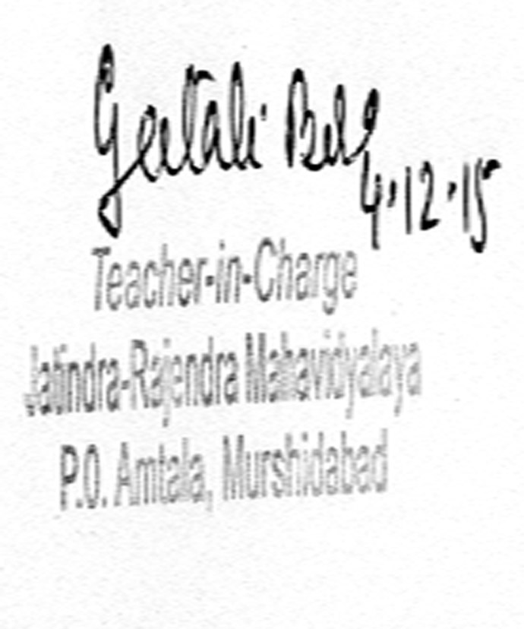
_______________________________
Signature of the Teacher In Charge

_______***_______

Annexure I
Abbreviations:
CAS - Career Advanced Scheme
CAT - Common Admission Test
CBCS - Choice Based Credit System
CE - Centre for Excellence
COP - Career Oriented Programme
CPE - College with Potential for Excellence
DPE - Department with Potential for Excellence
GATE - Graduate Aptitude Test
NET - National Eligibility Test
PEI - Physical Education Institution
SAP - Special Assistance Programme
SF - Self Financing
SLET - State Level Eligibility Test
TEI - Teacher Education Institution
UPE - University with Potential Excellence
UPSC - Union Public Service Commission

***************
ANNEXURE 1
JATINDRA RAJENDRA MAHAVIDYALAYA
ESTD – 1986
P.O- Amtala, Dist – Murshidabad Pin Code – 742121
ACADEMIC CALENDER 2012-13
Month | Teaching days | Commencement of Classes | Exam days | Scheduled breaks & other activities
JULY | Nil | - | 22 (University Exams) | -
AUGUST | 18 | Ist, 2nd & 3rd year classes | Nil | Independence Day, Janmashtami, Id- ul fitre
SEPTEMBER | 22 | - | Nil | Students Registration for Part I Students, Freshers Welcome,& Social Function for students.
OCTOBER | 14 | - | Nil | Gandhi Jayanti, Mahalaya, Puja Vacation
NOVEMBER | 11 | - | Nil | Annual Sports, Guru Nanak Jayanti.
DECEMBER | 19 | - | Nil | College Foundation Day, Winter Recess.
JANUARY | 17 | - | Test Exams (Part III) | Students Union Election, Netaji Jayanti, Republic Day.
FEBRUARY | 18 | - | Test Exams (Part II) | Saraswati Puja
MARCH | 19 | - | Test Exams (Part II) will continue. | Holi, Good Friday
APRIL | 13 | - | Test Exams (Part I) | Bengali New Year, Mahabir Jayanti.
MAY | 06 | - | University Exams | Rabindra Jayanti
JUNE | Nil | - | University Exams | -

